[programme / Project Board Name] Board Meeting Agenda template

Date, time
Location / Video Conference details
Project Objectives:
[bullet point outline of the objectives of the initiative; all decisions taken need to move the project towards achieving these]

Time | Agenda Item | Paper | Attendees
Board Only Time
To-from time e.g.  1-1.10 | - Apologies | No
 | - Confirmation of Agenda | Yes
 | - Board – Conflict of Interest | No
 | - Confirmation of Previous Minutes and Action Register | Yes
 | - Project issues | No
Board Meeting
Context Setting
 | - Project Status Report (10mins)  No more than 10mins on this; focus the discussion on the “so what” and “now what” of the report content unless there are significant issues to work through | Yes | [Presenter Name(s)]
Decisions Needed
To-from time | - [Item Name] (20mins)  e.g. Variation Approval – additional funding request | Yes | [Presenter Name(s)]
To-from time | - [Item Name] (10mins) | Yes | [Presenter Name(s)]
 | - Add more items as needed
For Discussion
To-from time | - [Item Name] (10mins) | Yes | [Presenter Name(s)]
To-from time | - [Item Name] (15mins) | No | [Presenter Name(s)]
 | - Add more items as needed
For Noting (no Board discussion required)
n/a | - [Item Name] (15mins) | Yes | n/a
Next Meeting: [date & time]

Attendees
[name, role] | [name, role]
[name, role] | [name, role]
[name, role] | [name, role]
[name, role] | [name, role]

Forward Agenda
Meeting date A | [item name] | [Requester Name]
Meeting date A | [item name] | [Requester Name]
Meeting date A | [item name] | [Requester Name]
Meeting date B | [item name] | [Requester Name]
Meeting date B | [item name] | [Requester Name]
Meeting date B | [item name] | [Requester Name]
Meeting date C | [item name] | [Requester Name]
Meeting date C | [item name] | [Requester Name]

Tips & Tricks for Good Board Meeting Logistics
Don’t underestimate the importance of good logistics to help the Board do their role well. These tips & tricks will help to keep your Board well organised and ready to make good decisions!
For more advice or support contact Tregaskis Brown at https://www.tregaskisbrown.co.nz/

To help the Board members have informed discussions, all meeting papers need to be sent out at least 3 working days ahead of the meeting.

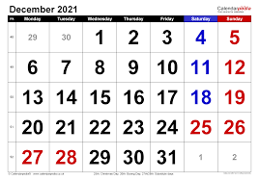

Keep 5-10mins of the meeting time unallocated; agenda item discussions almost always take longer than first planned. Having some spare time will help the Chair complete the agenda.

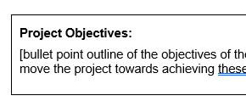
Including the project objectives in the agenda serves to remind the Board members of the PURPOSE of the project. Decisions taken in the meeting need to be about achieving these objectives.

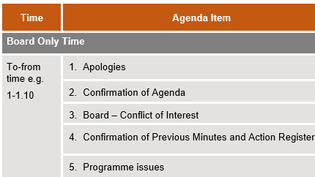
Board Only time is optional. Work with the Board Chair to determine if this is something s/he would like to introduce. It can be useful for the Board to work through their concerns before presenters come into the room / video call.

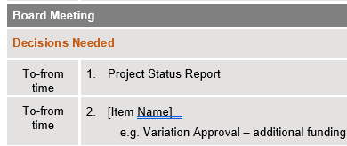
Prioritise the decisions needed to the top of the agenda. Often meetings run out of time so if critical decisions aren’t taken in the meeting this could hinder the project and put success at risk.

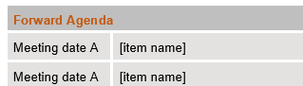
Including the (draft) forward agenda helps the Board members see what’s coming up for decision/discussion.
The forward agenda items are only in draft.
Aim to provide visibility for 2-3 forward meetings.

